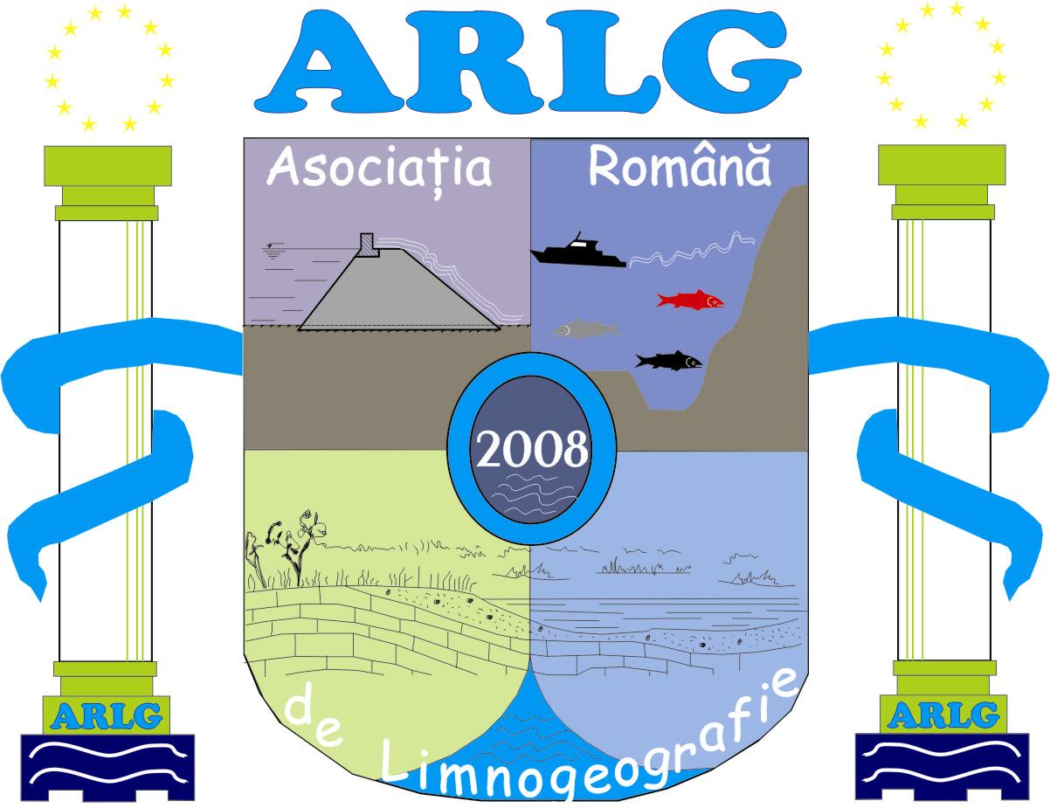



Valahia University of Târgovişte Romanian Limnogeographical Association Institute of Geography Bucharest
www.valahia.ro www.limnology.ro

International Conference
Geography, Environment and GIS
for students and young researchers
Targoviste, Romania, May 22-24, 2014
Official Conference website is:
http://www.limnology.ro/geg2014.html
Please complete this form and return by E-mail latest until April 18, 2014.

• e-mail: geg2014@limnology.ro

Registration
Delegate | Student | MSc | PhDs | PhD & PostDocs (<35 y)
Full Familiy name
Full First name
Company/University/Institution
Address
City
Postal Code
Country
Phone
Fax
E-mail

Type of presentation:
Oral | Poster

Themes and Topics
A. Geography
B. Environment
C. GIS

Abstract submission (Abstract is a part of registration form)
Title
Author(s)
University/Company/Institution
E-mail contact
Abstract (max. 800 words)
Keywords (max. 6)
Professor coord. (only for students and MCs)
Name and email

Field trip: Yes  No 

